Name: | ___________________________________________________ |  |  |  |  | Date: ___________
 | Year 11 Mathematics: Applications  Investigation 1, 2016  Topic – Forensic Science  In Class Component |  |  |  |  | 50  = %
Total Time: | 50 minutes
Reading Time: | 5 minutes
Working Time: | 45 minutes
Equipment: | SCSA Formula sheets, ClassPad calculator, Scientific Calculator, Take Home Component
Date out: |  | Week ____ Date _____________ |  | Date Due: | Week ____ Date _____________
Take home component weighting: |  | 0% of the year |  | In-class component weighting: | 10% of semester, 5% of the year
AIM: In this assessment, you will be investigating how mathematics is used in solving crimes, through Forensic Science. You use your CAS ClassPad for this investigation, in particular the spreadsheet function.

MUDDY FOOTPRINTS

A week after discovering the body of Py Thagoras at Lake Walyungup, Inspector Jack and Dr Math were called to a crime scene at a beach house in Warnbro. On entry, Inspector Jack discovered the body of Correl Ation, a 28 year old female in the bedroom. The crime scene investigators processed the scene and discovered two sets of prints outside the bedroom window. One set of prints had a footprint length of 27 cm, and the other set of prints had a stride length of 70 cm.

Dr Math explained to Inspector Jack that the height of a person could be estimated using footprint length or stride length. According to Dr Math, a person’s height is approximately 6.2 times the length of their footprint, and their stride length is approximately 35% of their height.

1. | [1 mark]
 | Determine the rule to find the height of a person given their footprint length:

2. | [2 marks: 1, 1]
 | Determine the height of the following people, given their footprint length:
a) | 12 cm | b) | 31.5 cm

3. | [2 marks: 1, 1]
 | Determine the length of a person’s footprint, given their height. Give your answer correct to the nearest mm.
a) | 201 cm | b) | 1.45 m

4. | [1 marks]
 | Write the rule for determining the height of a person using their stride length algebraically, with h representing the height of the person, and s representing the stride length.

5. | [2 marks: 1, 1]
 | Determine the height of the following people, given their stride length:
a) | 67 cm | b) | 546 mm

6. | [2 marks: 1, 1]
 | Determine the length of a person’s stride length, given their height:
a) | 205 cm | b) | 1.67 m

Inspector Jack identified three suspects for the murder of Correl Ation.
- Anne Sirs – Correl’s co-worker. Anne missed out on a promotion overseas because it was given to Correl.
- Sol Ootions – Correl’s boyfriend. Correl dumped him last weekend when she got promoted.
- Mark Inkey – Correl’s former boss. He was sacked after Correl discovered he was stealing from the company.
Inspector Jack used the Police Database to determine the height of each of the suspects. The information he discovered is compiled below.
Name | Height
Anne Sirs | 198 cm
Sol Ootions | 179 cm
Mark Inkey | 186 cm

7. | [10 marks]
 | Dr Math reasoned that one set of prints belonged to the victim. If Correl was 172 cm tall, who is the murderer? Show reasoning for your answer.
SCHOOL ZONE INVESTIGATION

Inspector Jack is a very busy detective. He has been called to investigate speeding parents on a stretch of sealed road outside a school in Rockingham. If he can prove that the cars were travelling in excess of 40 km/h, he can set up some cameras to catch the offending drivers and fine them.

The stopping distance for a car is based on the driver’s reaction time (thinking time) to apply the brakes and the actual braking distance for the car (v is the speed the car is travelling at).

Reaction time = 0.208 x v Braking distance = 0.025 x v²

8. | [4 marks: 1, 1, 1, 1]
 | Determine the reaction time in metres for cars driving at the speed below. Give your answer to the nearest whole number.
a) | 30 km/h | b) | 45 km/h
c) | 53 km/h | d) | 60 km/h

9. | [8 marks: 2, 2, 2, 2]
 | Determine the total stopping distance for cars travelling at the following speeds. Give your answer to the nearest whole number.
a) | 33 km/h | b) | 51 km/h
c) | 65 km/h | d) | 70 km/h

10. | [3 marks: 1, 1, 1]
 | Determine the speed of the driver, given the following information.
a) | Reaction distance of 7.696m.
b) | Reaction distance of 9.568m.
c) | Braking distance of 12.1m.

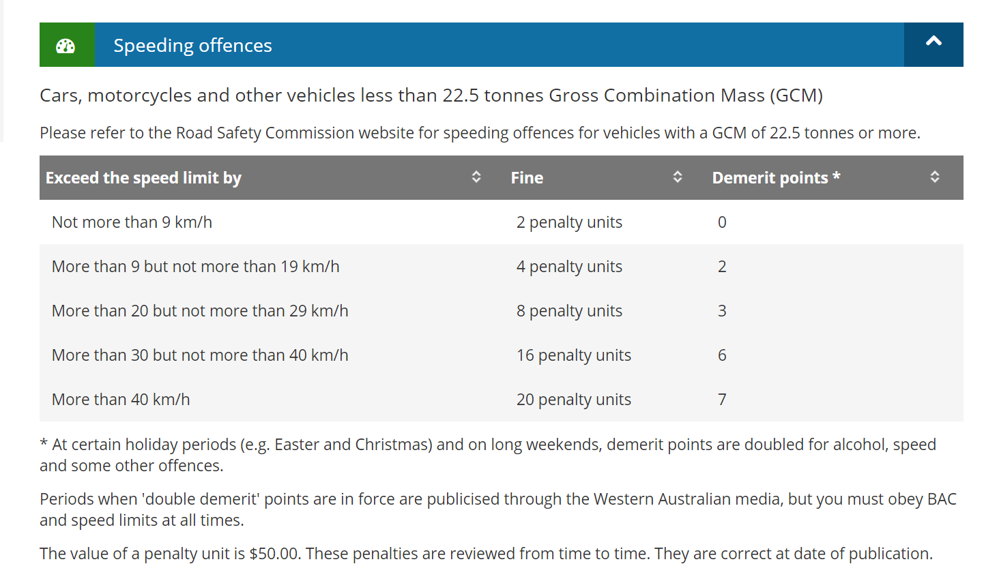

11. | [15 marks]
 | Speeding fines and points are allocated on a sliding scale. Determine the speed and hence the fines and points allocated to the following drivers. Remember, the speed limit in a school zone is 40 km/h.
 | Reaction time = 0.208 x v Braking distance = 0.025 x v²
Parent | Reaction Distance (m) | Braking Distance (m) | Total Stopping Distance (m) | Speed  (km/h) | Demerit points | Fine ($)
Mr B. Racer | 12.48 |  | 102.48
Ms H. Oon |  | 72.9 | 84.132
Mr S. Gonzales |  | 129.6 | 144.576
Mr P. Plater | 8.736 |  | 52.836
Ms L. Driver | 7.28 |  | 37.905

